**Use MAMP to run this project**

This project will build a photo gallery using jQuery for your travel photo sharing site as shown in following picture.

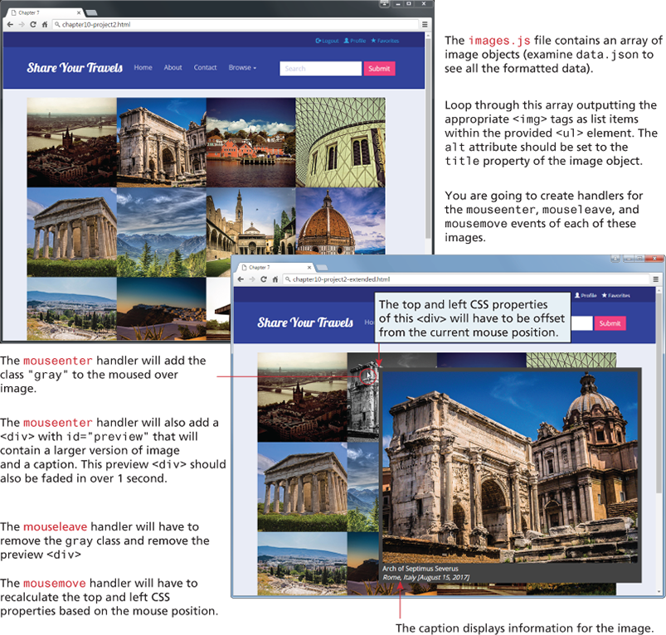

**Requirements**

When the document is loaded, you will make an AJAX call, download the data.json file (it contains an array of image objects) and display images on your html page. When the user hovers over the image, show the larger version of the image along with the caption. See instructions for details.

**Instructions**

1. Examine HW2.html in the browser and then editor. You have been supplied with the appropriate CSS (the relevant classes are in gallery.css), html, and JavaScript data files (data.json which contains the data in an easy-to-read format). The images are supplied in two folders: images/square (for the gallery) and images/medium (for the popup).
2. Loop through the images array and using the appropriate jQuery DOM methods, add the appropriate <img> tags to the supplied <ul class=“gallery”> element. The image filenames are contained in the path property of each image object. Set the alt attribute of each <img>to the title property of the image object.
3. Use jQuery to attach handlers for the mouseenter, mouseleave, and mousemove events of the square images in the gallery.
4. For the mouseenter event, use jQuery to add the “gray” class to the square <img> under the mouse. If you examine that class, you will see it sets the filter property to grayscale(). Hint: remember that $(this) within an event handler references the DOM object that generated the event.
5. Also for the mouseenter event, use jQuery to generate a <div> with an id=“preview” (the styling for #preview is already defined in gallery.css). Within that <div> add an <img> element that displays the larger version of the image. Underneath that <img> add a <p>element for the caption (image title, city and date taken). The alt attribute of the square image under the mouse contains the image title.
6. You will need to use jQuery to set the left and top CSS properties for the #preview<div>. You can retrieve the x, y coordinates (via the pageX and pageY properties) of the current mouse position from the event object that is passed to your event handler. You can calculate the new position by offsetting by some amount from the mouse x, y position.
7. Finally, once the #preview <div> is constructed, simply append it to the <body>.
8. For the mouseleave event, remove the “gray” class from the square image under the mouse. Also remove the #preview<div> from the body.
9. For the mousemove event, simply set the left and top CSS properties for the #preview <div> using the same approach as described in step 6.

**Testing**

1. Verify the code works when mousing over the images. Be sure that the caption is displaying the correct information.
2. Don't worry if the pop-up image is “off screen” when mousing over images on the edges of the browser.

**Deliverables**:

Screenshot of the results

HTML and JS files

Zip your files into a single file and name it as HW2-yournetid.zip.